

 ProQuest CrossLinks™

What are CrossLinks.

ProQuest CrossLinks are a means of linking out of ProQuest to other holdings that your library may hold.

Imagine your library has both ProQuest and Periodical Contents Index Full Text (PCIFT). Within the ProQuest subscription, the publication Journal of Memory and Language is citation only. However, within your PCIFT subscription this publication is full text. It would be good be able to link from ProQuest to the full text version of the journal within PCIFT. This can now be done using CrossLinks.

How does this work?

The first thing you will need to do is decide which journals you wish to link out of ProQuest from and where you would like to link to. Let’s take the above publication above Journal of Memory and Language as an example.

- Log into your LAD account and go to the section -

Library Holdings including ProQuest CrossLinks

If you seen nothing on this page it is because library holdings has not been set up. Please contact ProQuest customer services who will arrange for this to be included in your account.

You should see a page like this. Please do not be confused by the line CHADWYCK HEALEY SBUILD. Your institution name will appear here.

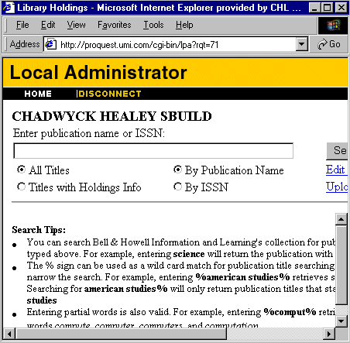

(fig 1.0)

- In the first box, enter the name of the citation only journal in ProQuest from which you wish to provide a link. In this instance you would type in Journal of Memory and Language.

- Click Search and your LAD will search through ProQuest for this title.

You should now see a box as below.

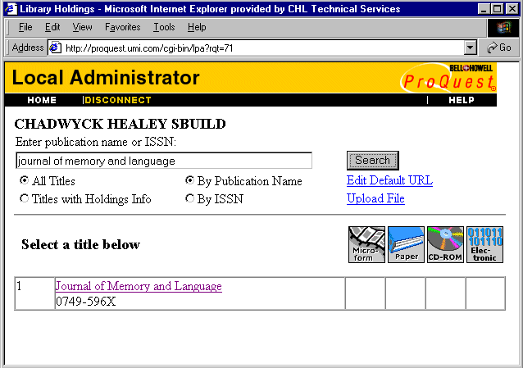

(fig 1.1)

The title Journal of Memory and Language has appeared.

- Click on this link and you will be taken to the following screen

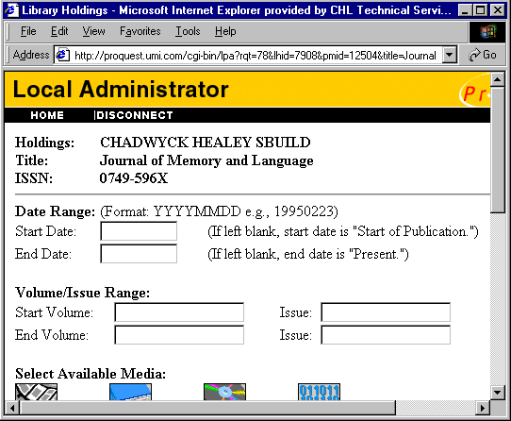

(fig 1.2)

- The next step is to fill in the boxes that describe the links.

Date Range:

The date range of the journal you wish to link to (in this instance the Journal of
Memory and Language within Periodical Contents Index Full Text). If left blank
the start date will appear as “Start of Publication” and the end date will appear
as “Present”

Volume/Issue range:

The range of volumes and/or issues that are within the journal to which you wish to link. If this is left blank the volume and issue information will not appear with the CrossLink.

Select Available Media:

The box laballed Electronic must be ticked for the CrossLink to appear in ProQuest. Any additional media type can also be ticked.

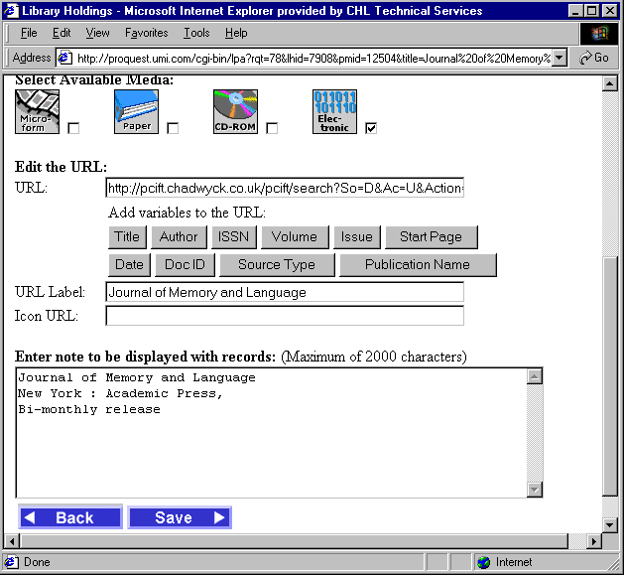

(fig 1.3)

Edit the URL:

URL:

This is the URL of the Journal (or otherwise) to which you wish to link. In this instance the URL for the Journal of Memory and Language within PCIFT.

URL Label:

The name of the link that will appear next to the CrossLink.

Icon URL:

Path to an icon that will appear with the CrossLink.

Enter note to be ….

Additional information describing the link.

- Once this information has been added, click the save button. The information will be saved and each time a user comes across an instance in ProQuest of the Journal of Memory and Language, they will see an additional local holdings icon next to the citation icon (as below)

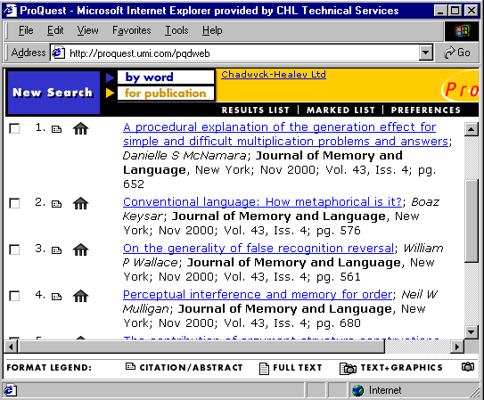
(fig 1.4)

- Navigate down to the article level

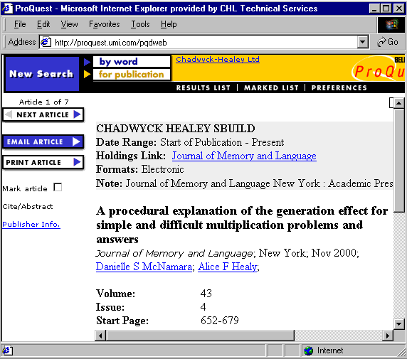

fig 1.5)

- Click on the Holdings link to be taken to the Journal of Memory and Language within PCIFT (see over)

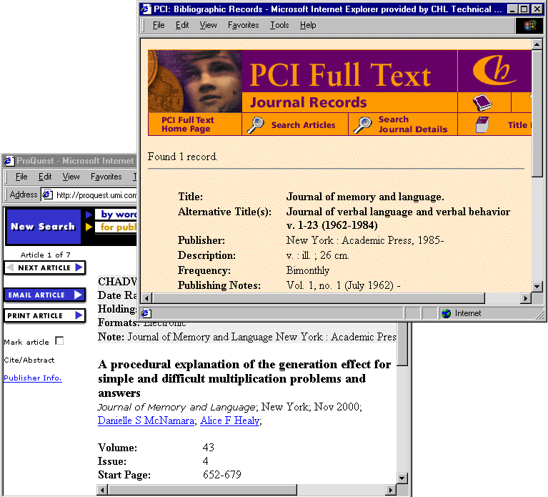
(fig 1.6)

A separate browser will open allowing the user to easily navigate between the two.

Using CrossLinks dynamically

As well as providing static links to other resources as above, it is possible to specify a custom format for a dynamic URL.

In this way, for example, when a user accesses a citation only journal, they could be given the option of either searching across an OPAC or an SFX for the specific article or journal. The search variables are taken from the ProQuest bibliographic information and dynamically added to the URL.

For instance, if you wished to create a link to dynamically search an OPAC for the publication name of the citation only journal you have accessed in ProQuest, the following URL would be specified to start with (this will open a search in this particular OPAC)

http://university.edu/opac/search/title=<

Additionally the variable <PUBNAME> would be specified by clicking on the button PUBLICATION NAME. The end result will be a URL which looks like

http://university.edu/opac/search/title=<PUBNAME> (as below in figure 1.7)

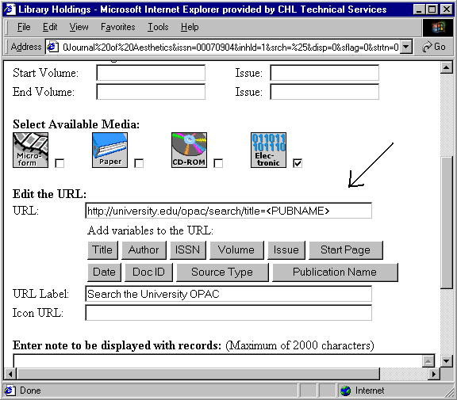
(fig 1.7)

.

This is how it works

- The user has found a CrossLink from the British Journal of Aesthetics in ProQuest. The link invites the user to search their OPAC.

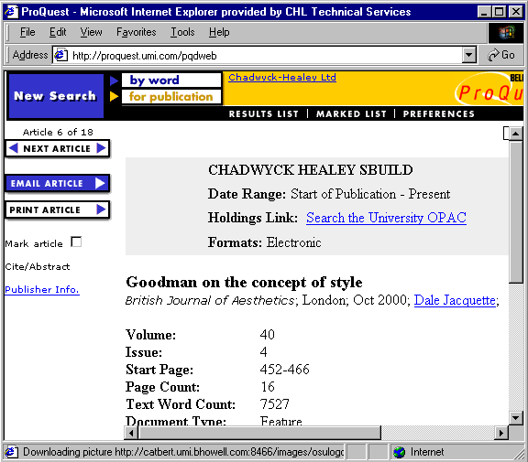
(fig 1.8)
.
- The user clicks on the link Search the University OPAC

- ProQuest extracts the Publication name (the British School of Aesthetics) as requested in the CrossLink information in figure 1.7 and adds it to the URL as below

http://university.edu/opac/search/title=British%20Journal%20of%20Aesthetics

- The user is then forwarded via this link to the OPAC which conducts a search for the journal (see over)

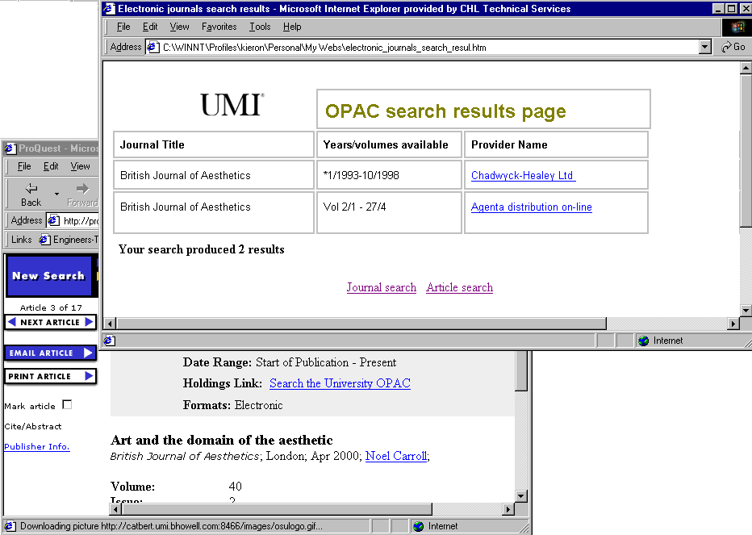

Again, a separate browser is opened allowing the user to easily navigate between the two databases.

SFX

ProQuest CrossLinks also supports the OpenURL format for linking to SFX resources.

Useful Links

For information on how to upload library holdings into ProQuest please see

http://www.umi.com/hp/Support/LHAdmin/LHDoc.html

For Frequently asked questions, please see

http://proquest.com/hp/Support/PQD/PQCrossLinks.html

