What is ProQuest Digital Dissertations --

ProQuest Digital Dissertations contains citations and abstracts of doctoral dissertations and masters theses for all subject areas from over 1,000 accredited colleges and universities from around the world (majority from North America). The database includes citations for materials ranging from the first U.S. dissertation, accepted in 1861, to those accepted as recently as last semester. Those published from 1980 to present day include 350-word abstracts, written by the author. Citations for master's theses from 1988 to present day include 150-word abstracts. Of the 1.5 million titles listed, Digital Dissertations offers free preview of the full text of the first 24-page of most dissertations beginning in 1997.

Keep in mind that full-text PDF in computer file format of dissertations is only available for those dissertations published from 1997 to present day. Some dissertations offered in this database may be found in library collections, others may be purchased if you choose to order them through this ProQuest database.

Accessing ProQuest Digital Dissertations --
ProQuest Digital Dissertations can be accessed in two ways:
A. Via the Library Homepage (http://www.univ_name/)
1. At the Library Home Page, under Databases, select by Title.
2. Click on ProQuest Digital Dissertations .
B. Directly at URL: http://wwwlib.umi.com/dissertations/
Or http://wwwlib.global.umi.com/dissertations

1. At the Welcome page, click on the Enter button, or the SEARCH button at the top of the screen.
2. By default, the BASIC search page is displayed. You may click on the ADVANCED tab for complex searches.

Searching ProQuest Digital Dissertations --
There are two different search screens for searching ProQuest Digital Dissertations – the Basic Search screen, or the Advanced Search page. You can choose which searching method you want by clicking on the appropriate tab at the top of the search page. Hint: Owing to the large size of the dissertation database, some searches may take several minutes before returning results. To improve performance, try making your searches as specific as possible.

Basic Search – For a general topic or keyword search, simply type your search term in the text box. You can focus the search for that term to a specific portion of a citation or abstract by selecting from the drop down menu to the right of the text box, and you can also use Boolean operators to combine two or more search terms to create a complex search. This search screen also offers the ability to restrict your search to a certain publication date by using the Date from form at the bottom of the search screen. For help in using operators and in crafting your search strategy, check the Searching Tips section of this guide. When you have finished creating your search, click on the blue Search button.

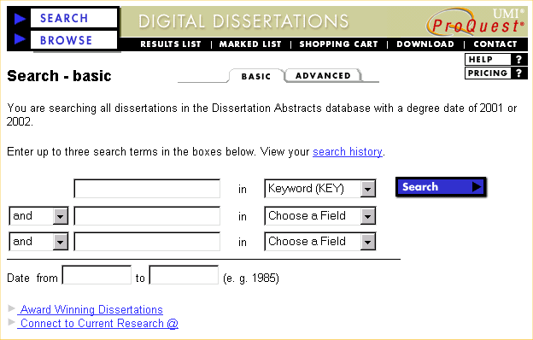
Quick Tip:

- Enter one or more words/phrases in the search text box(es).
- Select a field to be searched in from the pull-down menu.
- Enter a date range, e.g., 1997 to 1999, if desired.
- Click on the Search button.

Advanced Search – The Advanced Search page allows you to craft a complex search using Boolean operators to combine search terms, searching using phrases, searching by field operators, and combining terms with previous searches. Type your search strategy in the Build Query box. Listed below are some ways you might craft your search.

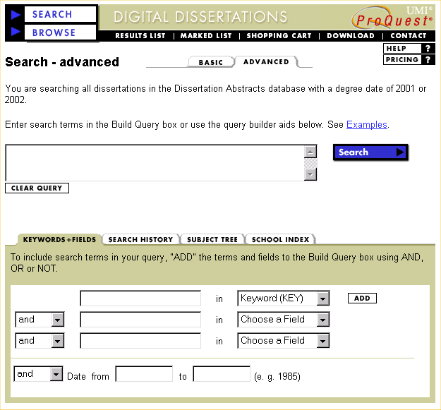
Quick Tip:

- Enter search terms, using the search syntax introduced below, in the Build Query box.
- Click on the Search button.

Note: For tips on “Subject Tree” and “School Index”, please refer to the section: Field Specific Search Tips at the end of this guide.

Field Operators -- Each record or abstract is broken down into informational fields -- AU for author, or TI for title, etc. You can limit your search to searching just within a specific field of information. To do this, type the field code you wish to search within, followed by the search term placed within parenthesis. For example, ti (biology) will search for all dissertations that have the word 'biology' in the title field.

Searching using Phrases -- To use a phrase as a search term, simply place the phrase within parenthesis. For example, keyword(cross country skiing) will search for all documents containing the phrase ‘cross country skiing’.

Combined Searching -- You can combine terms, phrases, and/or previous searches to create a new search by using the Boolean operators AND, OR or NOT (see Searching Tips). You can also reuse any previous search that is displayed in the Search History window. Simply use the set number as part of your new search. Examples: #5 and biology, #2 and ti (computer), #3 not #4. For more information on these searches, or for help in phrasing your search, click on the help button or consult the Searching Tips section of this handout.

The Advanced Search screen also offers other features to aid in creating your searches. These features are located in the shaded box below the Build Query box, and you can select the feature you wish by clicking on the designated tab. Keywords + Fields offers drop-down menu searching similar to the Basic Search screen. Search History numerically lists all the searches you have performed, and allows you to access the result list for any of these searches by clicking on the numeric Hits total for a specific search. Subject Tree allows you to search and find specific subjects by following a linked subject tree. The School Index lets you search for specific institutions by university or college name. Each of these features has a button on the left that lets you add your results to your search.

 The author will be requested to provide English translation of the abstract and title if the dissertation is not written in English. However, the title and abstract will appear in the original language if translated version is not provided by the author himself/herself.

 The language field was introduced in 1988. To search for titles published prior to 1988, use the language desired with the word "text" in the title field (i.e. ti(Russian text)).

Search Results --
Once you submit a search, a brief citation result list will appear. Each brief citation will list the dissertation title, author, institution where it was written, and UMI dissertation number. To access the full citation and abstract, double click on the Citation + Abstract link. You can print the record or abstract by using the Print button on your web browser.
Some of the most recent dissertations will also offer a useful option – Preview. Preview lets you view and read the first 24 pages of the dissertation online, usually covering the table of contents and summary of the dissertation. Dissertations offering this option will be labeled with a 24 page Preview link below the brief dissertation citation. Click on this link, and 24 tiny “thumbnail” page images will appear. You can view any of those pages by clicking on the thumbnail image to open it. You can print any of these pages by using the browser Print button while that page is open.

You can mark citation lists for later printing, emailing, or downloading by clicking on the box beside the blue folder icon to the left of the record. The records can be unmarked by clicking again on the box. Note: You can also marked all titles in your result (to a maximum of 1,000 titles) with a single click by using MARK ALL button.

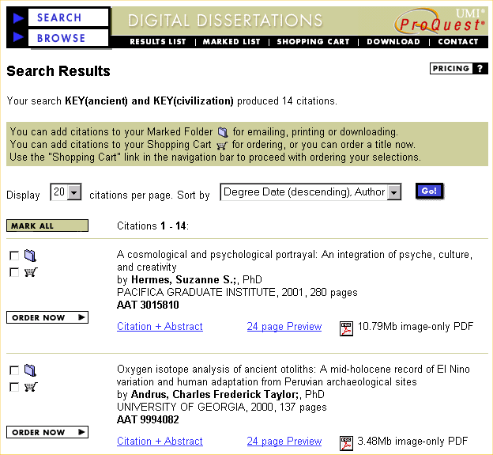

Print, Email or Download Selected Results --
Once you have marked the dissertations you want, click on the black Marked List button in the button bar at the top of the screen. You will go to a brief citation list of all the dissertation records you have marked. You can remove any dissertation from this list by clicking on the marked box to the left of the record. You have the ability to print, email or download these citations. You are also able to purchase copies of dissertations through this index; for information on purchasing, click on the Shopping Cart button on the black button bar.

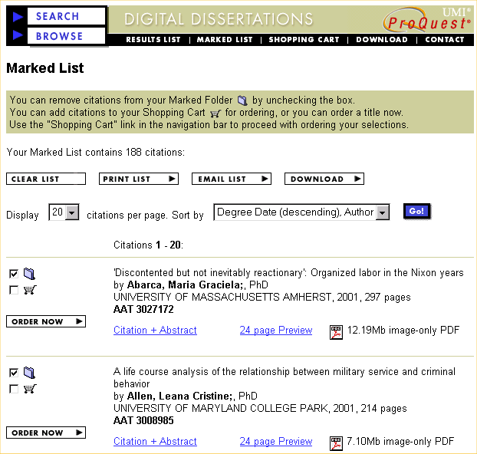

Print, Email, or Download Citation List: Click on the button for the appropriate format. In the Print/Download/Email Citations page you must select an option in the Output format and Sort by menus, and fill in the remaining text boxes. When finished, click on the button -- Print List, Email List, or Download List -- at the lower right. If you chose to print, a text version of your list will appear. Use the browser’s Print button to print, and then the Back button to return to searching.

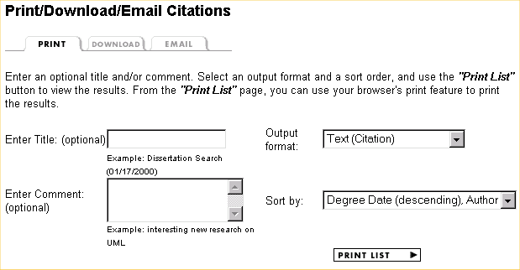

To Print the Marked List

- Enter a title and comment, if desired.
- Select an output format and a sorting option, if desired.
- Click on the PRINT LIST button.
- Use the browser’s Print function to print the list.

If you used email, a message will appear that the list has been sent, and you can use the Web browser’s Back button to return to searching. Note: do not enter multiple email address, only one email address is accepted at any one time.

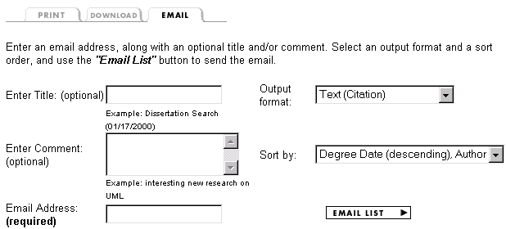

To E-mail the Marked List

- Enter a title and comment, if desired.
- Select an output format and a sorting option, if desired.
- Enter your full email address.
- Click on the EMAIL LIST button.

If you downloaded the list, The Save As . . . menu will appear. Select your computer’s floppy drive in the Drives: bar. Then select Plain Text (*.txt) in the Save File as Type bar. Type the file name you wish in the File Name: bar. Your file name must end in .txt in order to be able to access it later. When finished, click on the OK button. The list will be saved to your floppy disk. You can access this file in any word processing software by using that program's File:Open command.
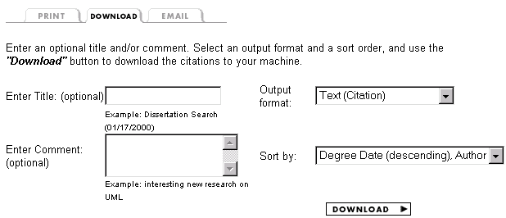

To Save the Marked List

- Enter a title and comment, if desired.
- Select an output format and a sorting option, if desired.
- Click on the DOWNLOAD button.
- In the Save As ... dialog box, choose a correct path and enter a file name, then click Save.

Searching Tips --

Boolean Operators -- You can use special operators to combine search terms and either broaden or narrow your search. Here are a few examples:
AND: education and internet education and internet in the same document
OR: education or internet education or internet, or both, in the document
NOT: education not internet education, but not internet
W/#: education w/10 internet education within 10 characters of internet -- where # is a number
PRE/#: education pre/10 internet education is 10 characters to the left of internet -- where # is a number

Phrases -- Separate words by spaces to specify retrieval of documents that have those exact phrases.
For example, title(cross country skiing) finds records with the exact phrase in the title field. For more information about searching by specific fields, see the Field Operators section below.

Using Parentheses --You can use parentheses for more complex searches, example:
ti((cable or satellite) and television) and sc(harvard)

Truncation -- You can broaden your search by typing a word root immediately followed by the truncation symbol ? . This will find all records containing any word that begins with the root word.
Truncation can be used to retrieve both singular and plural forms of a word, as well as various endings of the root word.
Example: title(biolog?)
Finds records with both biology and biological in the title field
Example: keyword(librar?)
Finds records with library, libraries, librarian, librarians, librarianship

Field Operators -- Each record is broken into several fields of information. When you search for a term without specifying a field, the retrieval software automatically searches the default field (the keyword or basic index field) that contains all words in the title and abstract fields of a record. A field search specifies which field should be searched for occurrences of the keyword or phrase. To search by field, use the specific field abbreviation, followed by the word or phrase you want to search in parentheses.

For detailed information about any of the fields, consult the Field Specific Search Tips section of the Help page in which can be located by the bellow button at the top-right of ProQuest Digital Dissertations:
.

Field Name | Field Abbreviations | Search Example
Abstract | ab; abs; abstract | ab(Iowa and Caucus?)
Adviser | ad; adviser; advisor | ad(Smith, Ann?)
Author | au; at; author | au(Hart, William)
Degree Date (year) | ddt; da; date; yr; year | DDT(1996); da(<1990)
Degree Awarded | dg; ddn; degree | dg(PHD)
Dissertation Database ID | disdb | disdb(DAI)
Dissertation Volume/Issue | disvol | disvol(DAI-B 56-02)
ISBN | isbn | isbn(91-554-3527-0)
Keyword (Basic Index) | keyword; bi | keyword(Cuba or Haiti)
Language of Dissertation | la; language | la(French)
Publication Number | pn;no | pn(AAT9634098)
School Name/Code* | sc; sch; school | sc(Ohio State); sc(0254)
Subject Name/Code ** | su; sub; | subject su(Cinema); su(0900)
Title | ti; title | ti(Fuzzy Logic)
* an index of school names and codes can be found at the School Name/Code entry in Field Specific Search Tips.
** an index of subject names and codes can be found at the Subject Name/Code entry in Field Specific Search Tips.

Field Specific Search Tips --

School codes can be found following the procedures below:
1. At the lower half of the Advanced Search page, click on the SCHOOL INDEX tab.
2. Enter a part of a school name in the text box.
3. Click on the Find Schools button to display all schools that contain the word you have entered.
4. Click on the Add button next to the school name to add the school code in the current search.

Subject names or codes can be found following the procedures below:
1. At the lower half of the Advanced Search page, click on the SUBJECT TREE tab.
2. Click on a broad subject area.
3. Click on the Add button next to the subject to add the subject code in the current search.

Purchase Full-text Dissertation --

- Click on SHOPPING CART at the top if you have checked the Shopping Cart box in front of each title you want to purchase in the results list. Or click on the ORDER NOW button next to each item in the results list.
- Select a desirable format for each dissertation.
- If you have chosen PDF (web download) for one or all of the selected items, you can only purchase the dissertation(s) online with a credit card. For formats other than PDF (web download), in addition to purchasing with a Credit Card, you can fill in and print out the order form to send to ProQuest Information and Learning (formerly UMI) via fax or postal mail following the instruction on screen.
- Click on the CHECK OUT button and enter necessary information.

