

SiteBuilder Administration Guide
A ProQuest Training Team Resource
April 2002

SiteBuilder security 3
Setting SiteBuilder Security 3
Max. link lifetime. 5
Link Prefix. 5
Restrict to these IP prefixes or full addresses 5
Link Password 5
Security Scenarios 6
Scenario One – on campus IP access only 6
Scenario Two – on and off campus access 7
Prerequisites 7
Scenario Three – on and off campus access 8
Scenario Four – off campus access only 8
What happens when a link is created? 10
What to do if your links stop working? 11
Error messages 11
How to change a link 11
How to change an entire page of links 14

SiteBuilder security

Probably the first and most important job of the administrator is restricting the use of SiteBuilder Durable links to only those who are entitled to use them under the terms of your ProQuest licence agreement.

Once security has been set, each time a link is created by anyone using one of your SiteBuilder accounts (either Builder or Administrator accounts) the security settings within this account will be added to the link (see page 12, What happens when a link is created?)

This is the first thing the administrator should do before using ProQuest. Once it has been done once it will only need repeating if your IP addresses change.

Setting SiteBuilder Security

Setting SiteBuilder security to restrict use of the links is simple and is done using the Administrator account. The details for this account are included in your welcome pack.

- Login as the SiteBuilder Administrator by going to http://proquest.umi.com/pqdweb and entering you SiteBuilder Administrator username and password. Alternatively, if you are using ProQuest already, go to Marked List and Durable Links, click on the Builder Login button and enter your Administrator username and password.

- Once you are logged in, click on Marked list & durable links from the Results drop down menu (if you have logged in via your ProQuest account you will not need to do this as you will be taken automatically to this page).

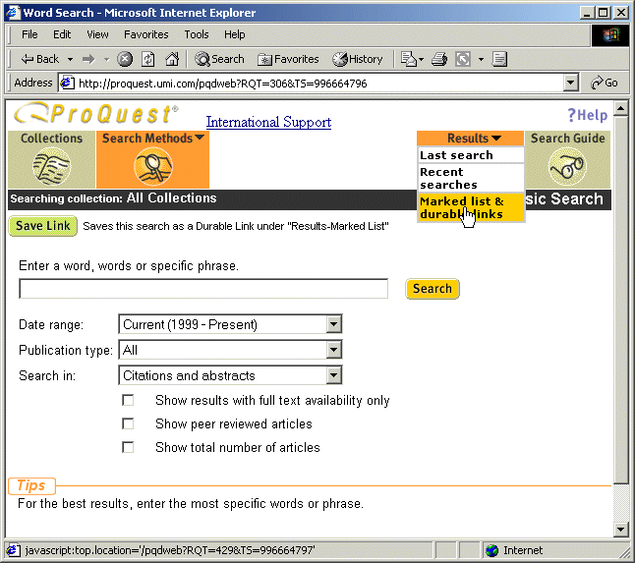
(Fig 1.0)

- Click on the Link Admin button

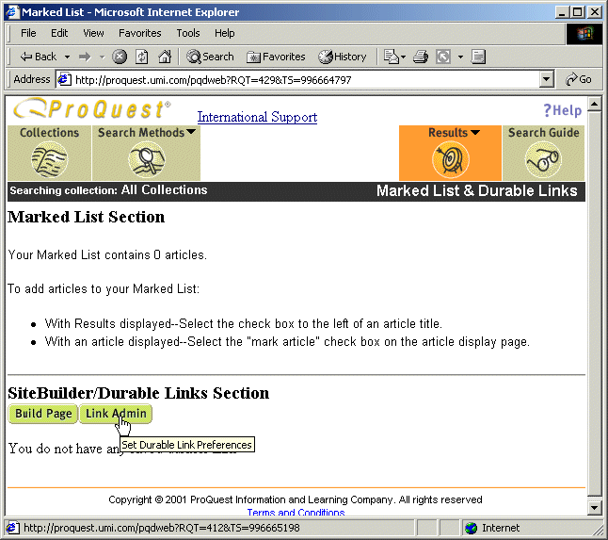

(Fig 1.1)

- You should now be at the following administration screen

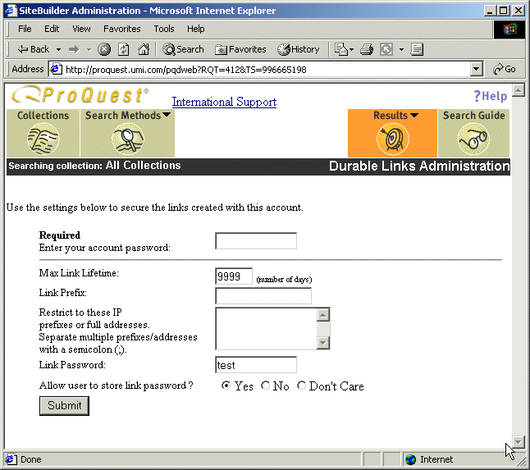
(Fig 1.2)

- Enter your account password in the first box (required every time).

- Set the security of the links using one or more of the following options in the remaining boxes.

Max. link lifetime.

Enter the number of days you wish the link to remain active (not a recommended way to control access). If left at 9999, links will remain active for 3 years (from December 2001 this will increase to 5 years)

Link Prefix.

Determine the routing of information to a local prefix.

This is used to route all SiteBuilder links through an institution’s proxy server in the event that off-campus users need to be identified by IP address. The off-campus user will need to set their browser to use the institute’s proxy server for connection to the Internet. Each time a link is clicked on, the ProQuest traffic would be routed though the institution’s proxy server and in so doing the institution’s IP address would be seen by the ProQuest server.

For this to happen correctly, your institute will need to set up its proxy server to route the traffic. ProQuest Information and Learning cannot provide support for this.

Another alternative is to set up a link prefix to a script (provided by ProQuest) on your web server. All traffic will be routed via this script and hence via your web server. This is the preferred method if you already have an existing access control method to your web or Intranet site.

For further information on the link prefix method, please see the scenarios listed below.

Restrict to these IP prefixes or full addresses

Add IP addresses here - ranges can be added e.g. 195.123.124.[1-255] or 194.187.7 - this box will not accept * and will accept up to 256 characters.

Link Password

If required, enter a password that users will need to access the links (this can not be used in conjunction with IP addresses as it is an either/or scenario)

Please note - If you decide to add a password to the links, checking the box “Allow users to store link password” will mean that anyone wishing to use the links will only have to add a password once (they will be prompted to store the password on their PC). After this, the password box will not appear again.

- Once you have added your settings, click on the button labeled Submit to save them.

Security Scenarios

Following are a number of scenarios outlining how you might best set SiteBuilder security. These are meant as a guideline only and you may wish to use your own strategy or a combination of those below.

There are four scenarios

- An institute wishing to give access to on campus users only via IP address.
- An institute wishing to give access to on and off campus users. This institute has its own web site security i.e. users must log into a virtual campus first.
- An institute wishing to give access to on and off campus users. This institute does not have its own web site security.
- An institute wishing to allow password access only.

Scenario One – on campus IP access only

Let’s say for instance you wish to make SiteBuilder links available to on-campus users only. By adding the IP range of the entire university, you could ensure that anyone clicking on the link had to do so from a computer within the campus.

- Follow steps 1-4 above. You should be at the following screen and will have entered your password in the first box.

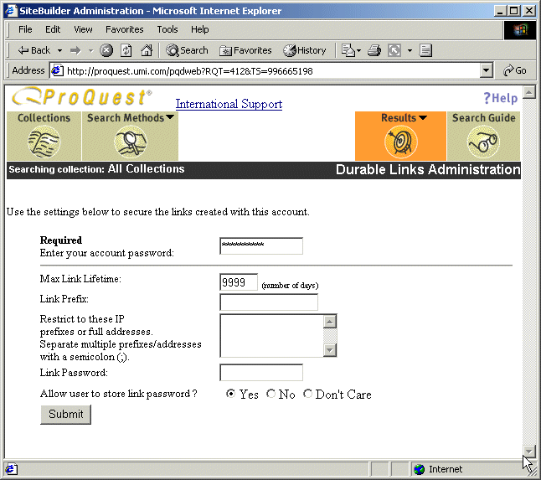 (Fig 1.3)

- Leave the rest of the boxes as default and go to the IP address box.

- Add your IP range and separate the addresses with a semi-colon.
Ranges should not include an asterisk (194.119 is sufficient for this range for example), and can be broken down using brackets e.g. 194.119.[234-255]

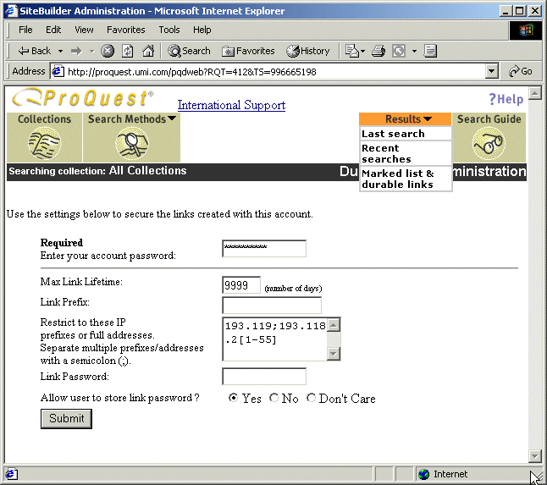

(Fig 1.4)

Now each time someone creates a link using the Builder or Admin account, the IP range will be added to the link. From now on every time the link is clicked on, SiteBuilder will ensure that the IP of the PC matches or falls within this range.

Scenario Two – on and off campus access

Prerequisites

- Institute level Intranet or Internet security (logging onto a virtual campus for instance).
- A Webmaster/developer familiar with the Perl scripting language.
- A Web server with Perl. (Perl version 5.04.02 was used for development and testing).
- LWP, HTTP, and URI Perl modules. These modules are included in the standard Perl distribution.

In this scenario, the institute has a virtual campus. Users must log into the campus and are then given access to certain pages. These pages may contain SiteBuilder Durable links.

The best way to achieve this is to

- Download the Perl script at http://www.proquest.com:8090/builder/pqdlink.txt, rename it to pqdlink.pl and install it on your web server.
(If you cannot access this script, please email tsupport@il.proquest.com who will send you a copy).
- Log into SiteBuilder and in the security screen specify a Link Prefix. This should be the route to the Perl script e.g. http://www.myschool.com/cgi-bin/pqdlink.pl. For all SiteBuilder links created with your account, the link prefix you specify will replace the default ProQuest Information and Learning prefix, ensuring that all link requests and responses are routed through your server.
- Add the IP address of the web server on which the script resides in the box entitled “restrict to these IP ….addresses”
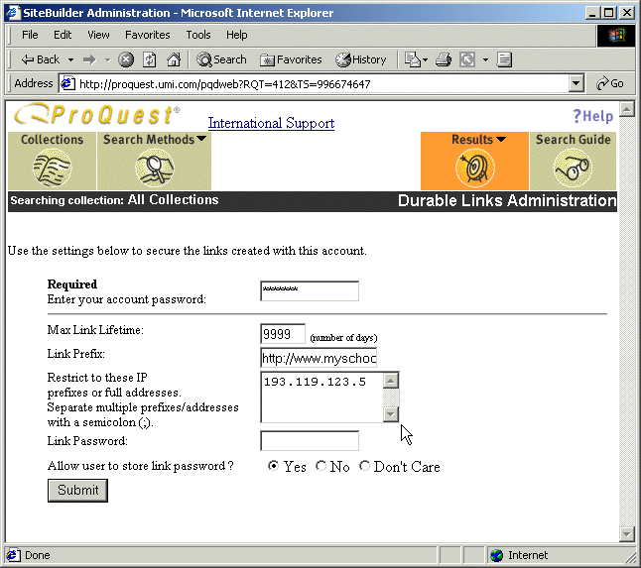
(Fig 1.5)
Now when you create SiteBuilder Durable links, the prefix will be added to the link in place of a ProQuest information and learning prefix. When users click on these links they will be routed via your web server. It is this IP address that will authenticated against. For off-campus users you should ensure that the perl script is protected using normal html security and that these users have to enter a password before the script will run.
This is the preferred method for accessing for both on and off campus users.

Scenario Three – on and off campus access
If you wish to access SiteBuilder durable links from both on and off campus but do not have your own web security in the form of a virtual campus for instance, there is really little to suggest other than asking for two SiteBuilder Administrator accounts. With one account you can specify an IP range and create links using this. With the other account you can specify a password and use this to create links. The downside of this is that you will need to manage two accounts and will need to create links twice, one for on campus, the other for off campus users. The alternative is to create one page of links and change it to your password account settings using the page update service (see page 20 How to change an entire page of links)

Scenario Four – off campus access only
If you wish to provide off campus access only using a password, the following steps should be taken.
- Follow step one of scenario one.

- Leave the link prefix and IP boxes empty

- Add a password to the box at the bottom and check the yes box next to “allow users to store link password”.

- You may additionally want to add a link lifetime to coincide with the end of each term or semester (see fig 1.6 over)

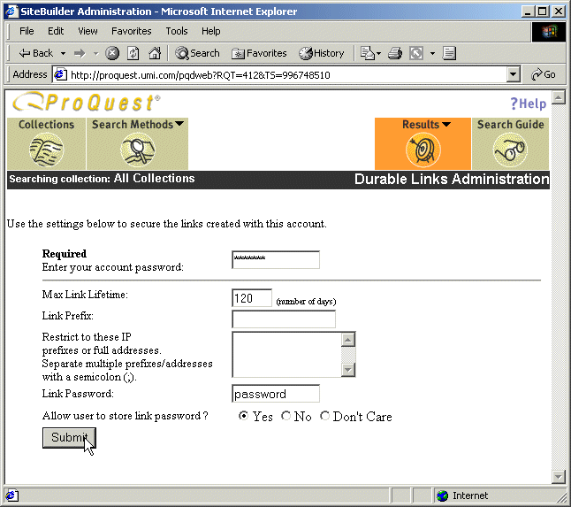
(Fig 1.6)

What happens when a link is created?

When you click on , SiteBuilder looks at the security details as set in the Administrator account, encrypts this and appends it to the URL.

So for instance, if the security details stipulated that users should fall within the IP range 193.123.156.1-255, a certificate containing this information would be added to the URL.

From now on, every time that it is clicked on, the URL is interrogated for its security information and a check run against the user to make sure that they fulfill the given criteria
Similarly, if the security details stipulated that a password was required, each time a user clicked on the link a password box would pop up.

If the security details are changed in the administration account, old URLs will retain the security that was set at the time they were created. It is important therefore to update the old links to reflect the new security using the page or link update service (available via http://training.proquest.com)

What to do if your links stop working?

Links can stop working for a number of reasons

- Your IT staff may change your institute’s IP addresses

- Someone may change your account

  - Password

  - IP addresses

- Or the link may simply have expired (if someone has set an expiration date)

Error messages

If you click on a link and the following message appears…

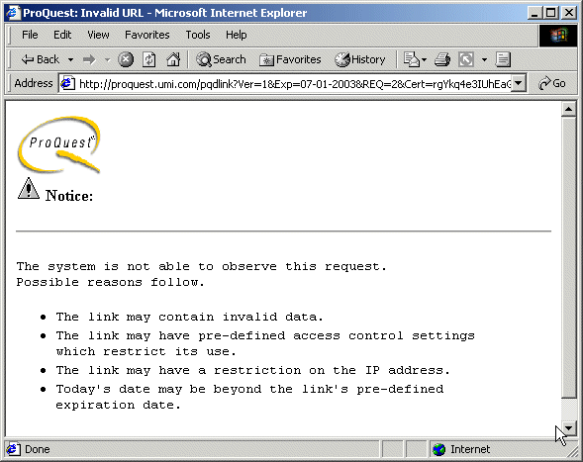
(Fig 2.2)

…it is very likely that something in your account has changed or, as is quite often the case, your IT staff have changed or updated your IP addresses. It is important to warn your IT staff that any changes they make to your institute’s IP addresses could have a knock-on effect on your SiteBuilder links.

How to change a link

First you will need to establish the nature of the problem

- Copy one of the links that is not working

- Go to http://training.proquest.com

- Under SiteBuilder Resources click on Tools and Resources

- Click on Link Editor and paste your link into the box that appears

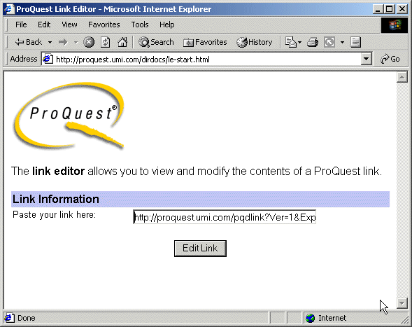
(Fig 2.3)

- Click on Edit Link

- You will be taken to the following page

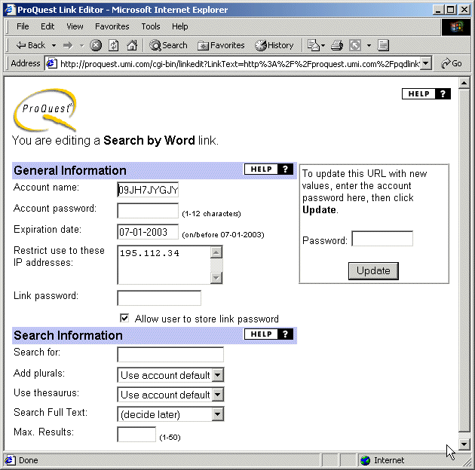
(Fig 2.4)

This page will break down the details of the SiteBuilder URL. Here you can check the security details of the link (not the password though). In this instance, use of the link is restricted to those users with computers with the IP address 193.129.114.5 (the proxy server in this case).

The first thing to do is check with your IT staff that the IP address has not changed. You can test this yourself by going to the URL http://www.umi.com/whoami this will check the IP address of your PC, or proxy server and return a page such as

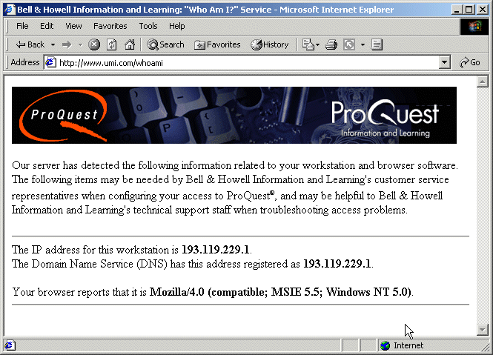

(Fig 2.5)

Notice in this instance that the IP address that the server is returning is different to that in the link (in fig 2.4). For this reason the link has stopped working. It may be that the IT staff changed the IP address of the proxy server.

Once you have verified that your IP address has changed, you will need to modify the links to reflect this -

- In the link editor, change the IP address to the new IP address

- Type in your password (right hand side only)

- Click on update

(see over)

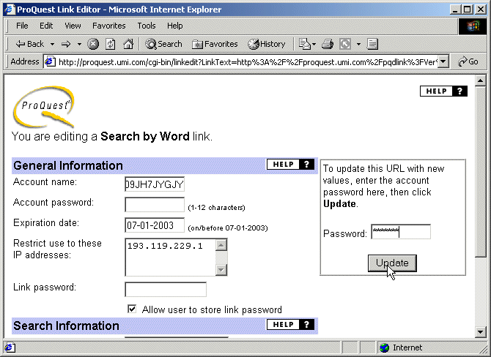
(Fig 2.6)

IMPORTANT – only add your account password in the second box down on the left if your account password has changed and you need to update the link to reflect this. Your account password must be added to the box on the right.

How to change an entire page of links

If your IP address had changed, it may be necessary to update the security information on all pages with SiteBuilder links. This can be done by using the Page Update Service.

- Go to Go to http://training.proquest.com

- Under SiteBuilder Resources click on Tools and Resources

- Click on Page Update Service. and enter the location of the page that needs updating.

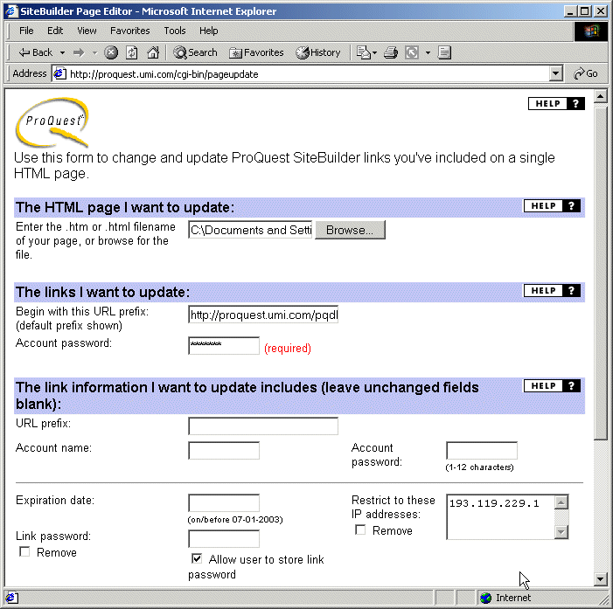
(Fig 2.7)

- Unless you are routing your links through a proxy or web server (see page 7 Link Prefix) leave the second box (URL prefix) empty.

- Add your account password to the third box down (required).

- Add your account name only if your account name has changed or you would like to swap a page of links from one account to another.

- Add your account password in the password box on the right only if you need to change this or if you are swapping links from one account to another (in which case you would change both the username (as above) and the password.

- To remove a password for links check the remove box underneath Link Password.

- To remove all IP addresses from the links, check the remove box underneath Restrict to these IP addresses.

Tip. If you need to create both IP address and password links, create IP address links first and then use this page to change them all to password links (you will need to change the account name and password, remove all the IP addresses and add a link password).

When you click Update, your page will display. All of the ProQuest SiteBuilder links on the page will be updated to reflect any changes you specified.
If your page contains images, you will not see them when you click Update. When your page displays, use your browser's File/Save As command to save your HTML page to a specific directory.
Take a minute to review any changes you've specified. After you click Update, you will not be able to use your browser's Back button to make further changes.

Contacts

For Technical Support contact tsupport@il.proquest.com

For Customer Services contact customer_services@proquest.co.uk

For assistance with SiteBuilder (non technical support) contact Kieron.wise@proquest.co.uk

Useful web sites

ProQuest and SiteBuilder Training Resource Center including information on dynamic linking, templates for web page customisation using SiteBuilder, masterlinks, and link editor - http://training.proquest.com/

To download this and other documents on linking via ProQuest www.learningbox.net (box one)

Notes

